Podman Installation:
1. Download the Podman Desktop (Don’t install it up yet. We will do that later):
- Windows - https://podman-desktop.io/downloads/windows
- macOS - https://podman-desktop.io/downloads/macos
- Linux - https://podman-desktop.io/downloads/linux
2. Enable the Virtual Machine feature. Open Windows PowerShell as an administrator and run the following command:
dism.exe /online /enable-feature /featurename:VirtualMachinePlatform /all /norestart
3. Reboot your machine.
4. Install WSL2. Open Windows PowerShell as an administrator again and run the following command: wsl --update
5. Reboot your machine.
6. Install the Podman service. Open Podman Desktop, and on the main page, click on Install button.
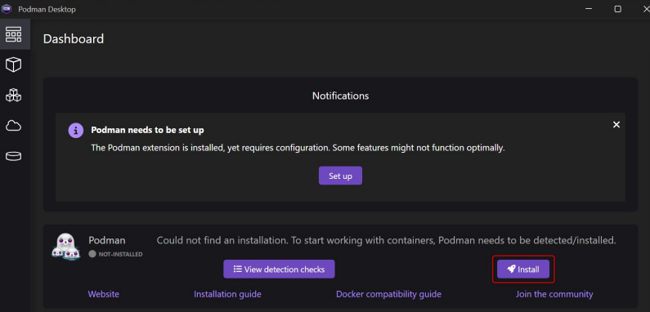
You should see all checks passed successfully (all checkboxes are marked green). If any of the checkboxes are red, ensure to review and complete the previous steps. In the Installation wizard, you can uncheck the Install WSL if not present option.
7. Reboot your machine.
8. Create a Podman machine to host the container.
DON'T USE the Initialize and start Podman option in Podman Desktop as it sometimes causes failures. Navigate to the Settings page, Resources tab, and in the Podman section, click on Create new to create a Podman machine.
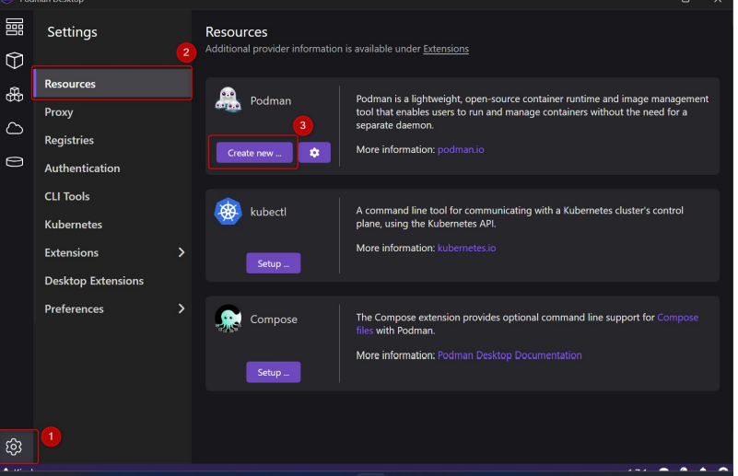
Depending on Podman version, set up the machine with the following settings below if you have these options. If not – proceed with default settings.
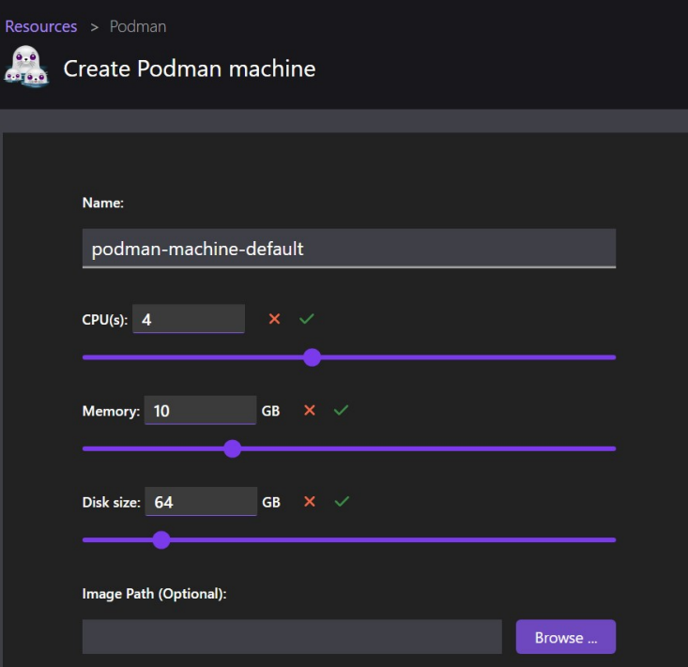
Now, set up the machine with the below settings. Make sure that the User mode networking is switched to Enabled.
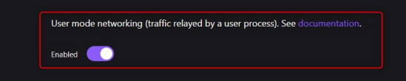

2. Installing Jupyter notebook:
Navigate to the images tab, click the pull button, then input docker.io/jupyter/pyspark-notebook
Please be advised that the image size is around 5 GB. Therefore, it might take a while to download. Ensure to use a decent internet connection.
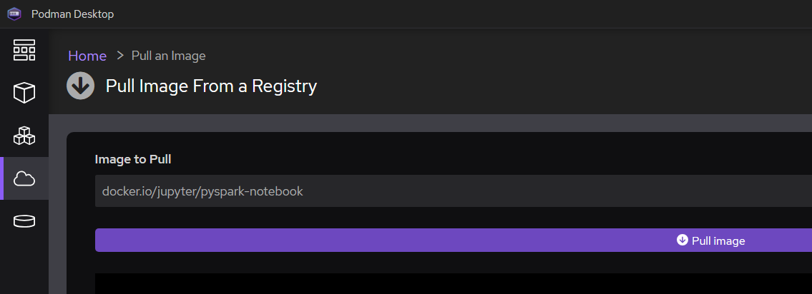
10. Open the new Terminal window and execute the command to create a new container:
podman run --name=jupyter_container -it -p 8880:8888 jupyter/pyspark-notebook
11. Open the browser app, go to http://localhost:8880/ and copy the token
(!) Make sure that you are using port 8880, not the one from the output of the podman run command, as we mapped default 8888 port to the port 8880.
Token is presented in the container logs:
12. Now you can access the Jupyter notebooks and can start working with them,

